RESUME

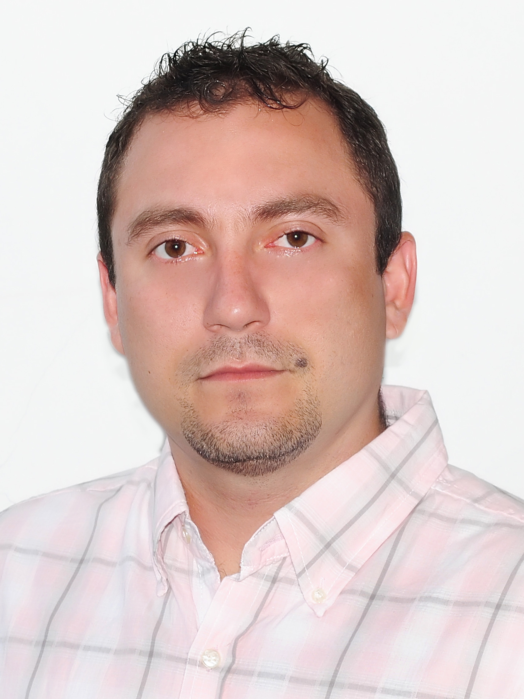
OCCUPATIONAL PROFILE: More than 12 years working in different human development activities, as control of personnel, construction, mechanical, designer, plumbing, software and hardware, installation of sewers, water systems and others

Adviser, consultant and auditor, management plans, planning Integrated Solid Waste Management, Environmental Management Systems, internal and external audits, project formulation, design: hydraulic structures, wastewater treatment plants, aqueducts, sewerage, macro-routes and routes micro collection and disposal of solid waste; Environmental Impact Assessments, Environmental Diagnostics Alternatives, certification processes, formulation, evaluation and project management, among other activities.

1. PERSONAL INFORMATION

NAME: ALEX G.
SURNAME: ESPINOSA
PHONE: (669) 234-2444
CITY: SAN JOSÉ CA.
ADDRESS: 5553 Walnut Blossom dr. apart G8
San Jose, CA, 95123

2. APPLIED STUDIES

PRIMARY: JULIO ARBOLEDA, Florida (Valle), 1989. COLOMBIA

HIGH SCHOOL: ARGEMIRO ESCOBAR CARDONA, La Unión (Valle), 1996. COLOMBIA

UNIVERSITY: UNIVERSITY LIBRE, SECTIONAL PEREIRA, FACULTY OF ENGINEERING, ENVIRONMENTAL ENGINEERING PROGRAM, Pereira (Risaralda), TITLE: ENVIRONMENTAL ENGINEER. 2004. COLOMBIA

OTHER STUDIES.

Seminars, conferences, meetings of researchers (in form of speaker and audience), research in the field of biologies, research in solid waste management with emphasis on utilization, among others.

Author of two research projects sponsored by the Free University Sectional Pereira, "Fauna rating the premises of the Free University Sectional Pereira 2002-2004; Solid Waste Organic alternative or problems 2001 - 2004.

Participated in the seminar/workshop on technical principles of climate environment for the design and construction of greenhouses. 2004. Colombia

Theoretical and practical course of environmental internal auditors, Pereira Technological University 2011. Colombia

Diploma in Integrated Management fundamentals of Applied Business Water and Water Pereira, Pereira Technological University in 2011. Colombia

Course. Urban development and housing. Inter-American Development Bank “BID”. 2018.

Course. The route to the Smart Cities Inter-American Development Bank “BID”. 2018.

English study, Silicon Valley Adult Education. January - June 2018. San Jose CA.

Plumbing Apprenticeship Program second year Villara Building Systems. San Jose CA.

English as a Second Language Villara Building Systems. San Jose CA.

SKILLS.

- Polite, friendly, honest.
- Healthy, learn fast,skillful hands.
- Good relationships with people.
- Speak Spanish.
- Systematic analysis of facts and logical problem solving.
- Easy adaptation to teamwork.
- I work under pressure.
- Interpretation, preparation of maps and diagrams.
- Management skills and communication.
- Analysis, evaluation and design of processes.
- Integration, coordination and implementation of new ideas in the treatment of waste water and the treatment, recycling, disposal, transportation and handling of solid-liquid ordinary or hazardous waste.
- Computer programs: Microsoft Office (Word, Excel, power point, Outlook), ArcGIS, AutoCAD, Hcanales, HiCalc, WinFlume, Google SketchUp, Google Earth, Map Source, Epanet, Corel, Flash, Dreamweaver, among others.
- Design of technical solutions for the prevention and control of pollution and deterioration of water resources, soil and air, that are socially viable, technically, economically and environmentally.
- Design of hydraulic structures.
- Plan and develop alternatives which foster sustainable use of natural resources.
- Design, manage, operate, maintain and optimize basic sanitation.
- Calculation and projecting of materials for infrastructure projects and others.

WORK EXPERIENCE.

Alex G. Espinosa, It is an environmental engineer high professionalism that since 2004 has offered providing environmental consulting services, Developing research, providing project management with environmental implications, both public bodies at national, regional and local levels, and large, medium and small business development projects of economic activities, infrastructure and especially related to integrated management of solid waste, treatment of discharged water, integrated watershed management, formulation of technical documents and work with vulnerable communities.

Its development has been driven by a team of professionals backed experience in disciplines related to the environment, engineering, administration, architecture, law, economics, finance, among others, with proven experience in providing solutions and consulting services, counseling, processing and management in all aspects concerning the efficient and friendly technical and technological development with the environment.

I have two years of experience in the area of installation of residential plumbing, in the different phases. And more than a year in the inspection and work coordinated with the supervisors and the inspectors that have allowed me to know more widely the codes related to the plumbing in the state of California.

I am currently working as a plumber installing at VILLARA company.

Hotel Maintenance 2015 - 2017: Bristol, Elan, Carlile and Campbell, Manager maintenance, Manuel (669) 206-7596.

C & J Services 2015, Boston MA, landscape, construction and maintenance. Manager Jose Polanco phone (781)6081025.
MIGUEL CABINETS, 2014, San Jose CA, Title: Laborer Function: development and installation of cabinets
Contract 0684, Governor of Risaralda, Departmental Health Professional services as an environmental engineer in the program of health and environmental safety framework of environmental health public health operational direction of the Secretary of health department. Develop and pilot implementation socializes risk maps in environmental health at the municipal level from IVC inspection visits, surveillance and disease control proposal. Carried out by environmental health technicians of the municipalities of categories 4th, 5th and 6th of Risaralda in five selected municipalities: Quinchia, Pueblo Rico, Marsella, La Virginia and Santa Rosa de cabal. Supervisor Diego Rincon Phone: (57) 63398300 / (57) 312 7068178

003 contract, service delivery, "Advanced Engineering Company LTDA" INGDA LTDA "Activities: Nazareth Hospital PGIRSH Update Quinchia Risaralda; Design of wastewater treatment Health Center Santa Teresita Irra Risaralda; Soundproofing Discotekas plans: Castle, My office, the bar, Moe, Regina, among others; System design gauging and sampling of wastewater Santa Rosa de Cabal (EMPOCABAL), 2012- January to May 2013.
148 and 263 contract to provide services, "Water and Sewerage Company of the city of Pereira" Water and Water ". Environmental Management System ISO 14001 Internal Auditor comprehensive, protocol design and issuance of dumping, environmental education business development and other activities, 2011. Supervisor. Claudia Jaramillo Phone: 3151233 E-mail cmjaramillo@aguasyaguas.com.co

Sampling and interpretation of laboratory discharged water system water treatment Jasmine Park Cemetery 2011 and 2012.

Project formulation, Foundation Possible Future Colombia 2010.

Training in solid waste management, Foundation Dream Colombiano 2010.

Plant design and construction of wastewater treatment, company Jasmine Park Cemetery, 2010.

Hydraulic design sewer, residential La Hermosa Santa Rosa de Cabal, 2010.

Hydraulic design, construction of the water treatment system of the company "Productos Químicos Andinos s.a. “PQA”, 2009.

Manager of the company development of environmental Systems “DSA” LTDA 2006 -2009.

Hydraulic design, construction of the water treatment system of the company "Utopa", 2008.

Research director U.T. Organic for the Environment. "Utopa" Pereira Risaralda 2007-2009.

Teaching in the areas of biology and chemistry of Pital Combia school on city of Pereira 2007-2009.

REFERENCES

JOSE POLANCO
COMPANY: C&J SERVICES
POSITION: Manager.
Phone: (781) 608-1025

CARLOS MURIAS
COMPANY: Miguel cabinets
POSITION: Manager.
Phone: (408) 476-0840

GEORGE MARTINEZ
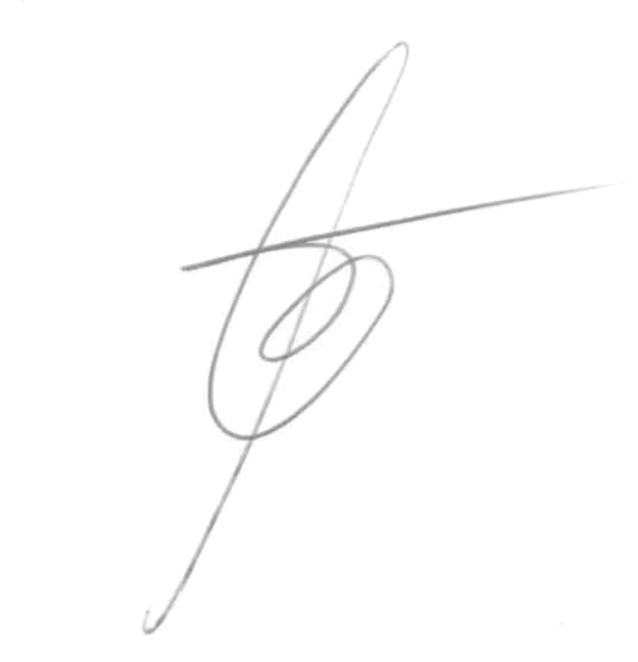
COMPANY: Villara Building System
POSITION: Instructor.
Phone: (916) 840-0744

ALEX G. ESPINOSA
Phone: (669) 234-2444.
San Jose CA.
Sample Wastewater Treatment Plant Design
Hydraulic design, "Productos Químicos Andinos s.a. “PQA”

